THE 3 CYCLES IN THE GREAT BARRIER REEF

The Water Cycle
The Water Cycle begins as the heat from the sun heats the water in the Great Barrier Reef, the water is then evaporated and turns into water vapor. The vapor then cools and rises forming clouds. When the clouds fill with water droplets, the water will then fall from the sky this is called precipitation. The water is then put back into the Reef. This is the water cycle in The Great Barrier Reef.

The Carbon Cycle
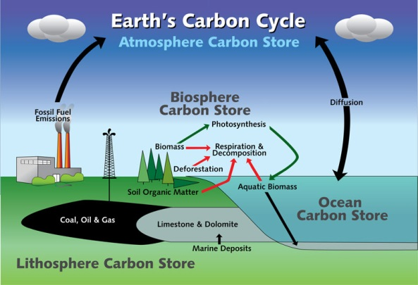
The Carbon Cycle starts when water from the reef absorbs the carbon dioxide that human, factories and other things produce rapidly. The carbon in the water then turns into carbonic acid. Now the water is changing, the organisms such as coral, plankton and many other organisms can’t live under acidification, which is now hurting them. This cycle restarts continuously happening.

The Nitrogen Cycle
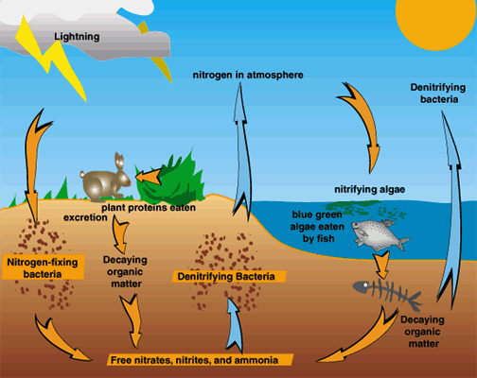

The Nitrogen Cycle occurs when the lighting in the atmosphere changes nitrogen gas into nitrogen compounds. Those compounds fall into the Great Barrier Reef (ocean) in a form of precipitation. The nitrogen-fixing bacteria on seaweed, marine algae and seagrass convert unusable nitrogen into usable nitrogen compounds. The compounds are now in the soil/sand and various sea plants such as coral, marine algae, and seagrass take in and use the compounds from the sand. Consumers then eat the coral and seagrass, the waste the consumers produce return the nitrogen compounds to the sand. Bacteria in the sand coverts nitrogen compounds into nitrogen gas which is released back into the atmosphere. The cycle starts over.

The Oxygen Cycle
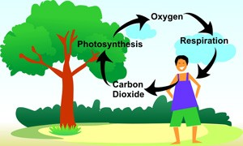

Humans take in oxygen and breath out carbon dioxide. Plants take in carbon dioxide and produce oxygen.

