Commensalism- One organism benefits the other is neither harmed nor helped

Mutualism- Both organisms benefit from each other

Parasitism- One organism benefits while the other is harmed (can even be killed)

COEXISTENCE BETWEEN SPECIES IN THE GREAT BARRIER REEF
1. 2 types of reef fish with a limited
amount of space making living work.

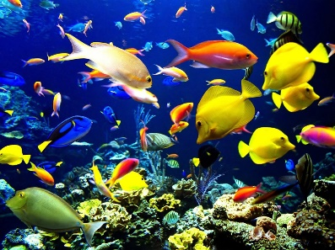

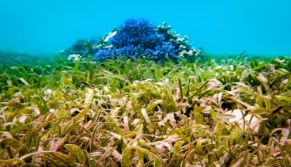
2. sea grass and coral (both plants) making space for each other in the great barrier reef and making it work.

3. Animals and plants
The plants and animals are living together keeping
ecosystem alive.
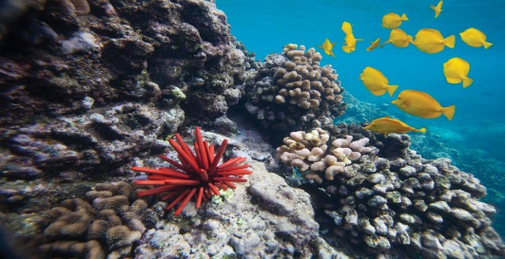

3 EXAMPLES OF COMMENSALISM
- Fish using coral as shelter (coral not benefitting nor harmed)
The coral is giving the fish a place to live.

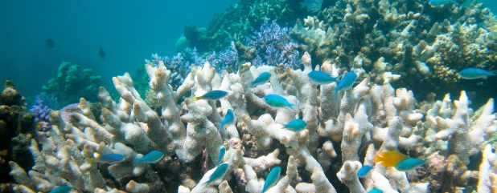

2. Clownfish and sea anemone {can be used for both commensalism and mutualism} clownfish living in sea anemone (doesn’t harm nor help the anemone) helps the clownfish, by giving it shelter. 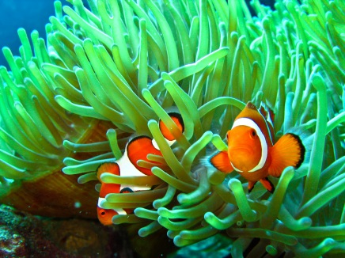

3. Pearlfish and sea cucumber (pearlfish uses the cucumber for protection) the sea cucumber is not affected.

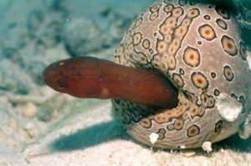

3 EXAMPLES OF MUTUALISM

1. Fish and coral (fish fertilizes coral) the coral protects the fish. They both benefit
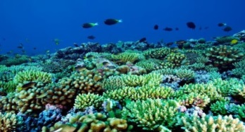
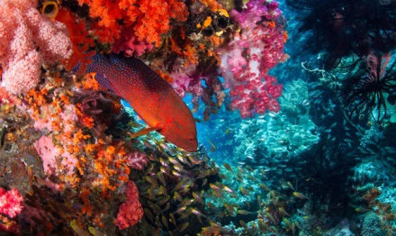

2. Sea anemone and clownfish (anemone protects fish) clownfish give anemone food.

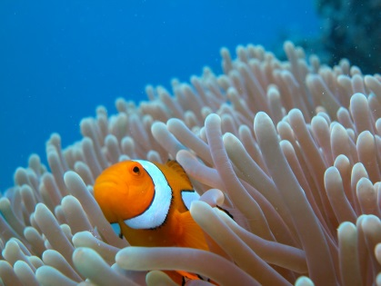

3. Algae and coral both get nutrients from each other.

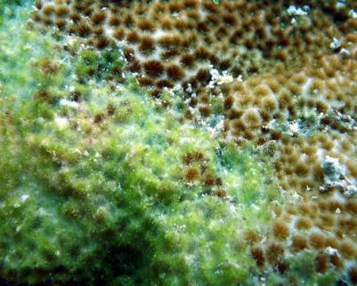

3 EXAMPLES OF PARASITISM
1. Sea spider and coral (sea spider takes nutrients from coral) affects coral because coral could have used the nutrients that were taken from it.

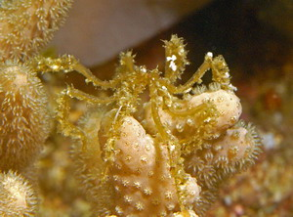

2. Monogena attaches itself to a fiddler ray fish and feeds off of it killing it.

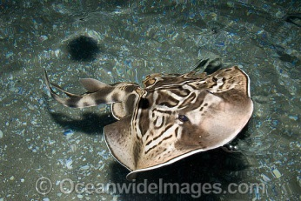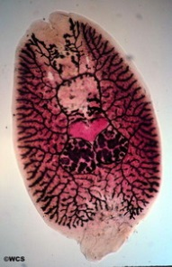

3. Trematode host on snail affecting the snails reproduction cycle.

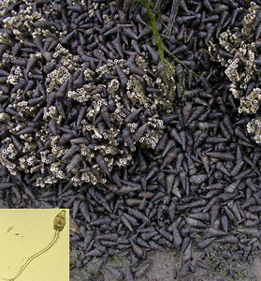

3 EXAMPLES OF COMPETITION
1. Tigershark and sea turtle (shark uses its teeth to cut through the turtles shell) while the turtle is using its shell for protection.

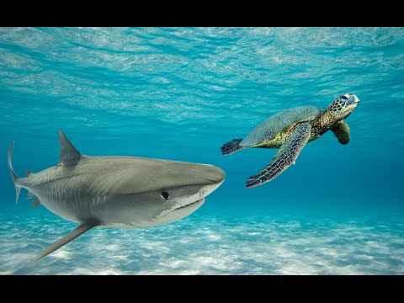

2. Sea sponges compete for space with corals.

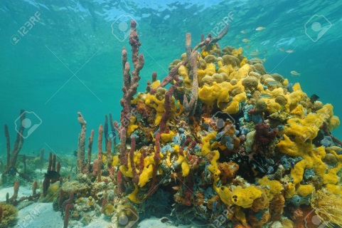

3. Sea birds compete with larger fish for smaller fish which is a food source for both sea birds and larger fish.
